Fakenham Infant and Nursery School

**Appendix 1: Draft Recording Form for Safeguarding Concerns**

Staff, volunteers and regular visitors are required to complete this form and pass it to [Sarah Gallichan/ Jo Barker / Polly Bramwell] if they have a safeguarding concern about a child in our school.

|  |  |  |  |
| --- | --- | --- | --- |
| Full name of child | Date of Birth | Tutor/Form group | Your name and position in school |
|  |  |  |  |

|  |
| --- |
| **Nature of concern/disclosure** |
| Please include where you were when the child made a disclosure, what you saw, who else was there, what did the child say or do and what you said.  Time & date of incident: |
| Was there an injury? Yes / No Did you see it? Yes / No |
| Describe the injury: |
| Have you filled in a body plan to show where the injury is and its approximate size?  Yes / No |
| Was anyone else with you? Who? |
| Has this happened before? Did you report the previous incident? |
| Who are you passing this information to?  Name:    Position: |
| **Your signature:**  **Time form completed:**  **Date:** |

Time form received by DSL:

Action taken by DSL:

Referred to…?

Attendance

Improvement

Officer Police School Nurse Children’s PSA Guidance Other Services Adviser

      

Date: Time:

Parents informed? Yes / No (If No, state reason)

Feedback given to…?

   

Pastoral team Tutor Child Person who recorded disclosure

Further Action Agreed:

*e.g. School to instigate a Family Support Process, assessment by Children’s Services*

Full name:

DSL Signature:

Date:

Fakenham Infant and Nursery School

□

**Body Map**

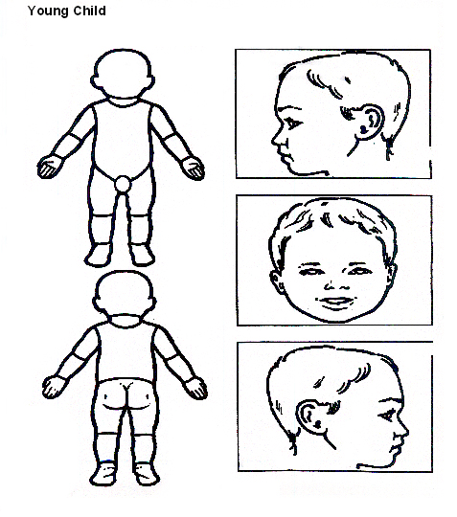

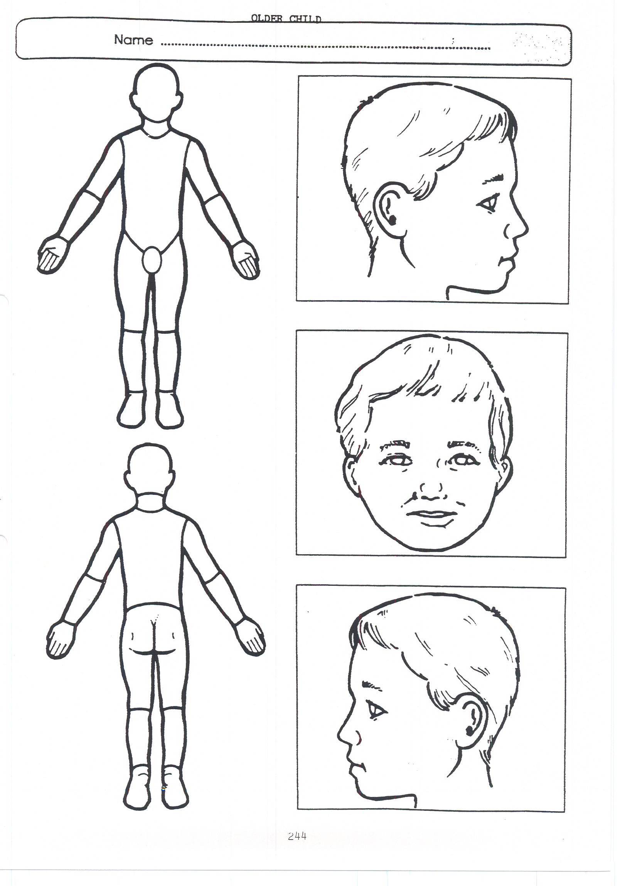

**Older Child**

Fakenham Infant and Nursery School

**Appendix 2: Safeguarding Induction Sheet for new or supply staff and regular visitors or volunteers.**

We all have a statutory duty to safeguard and promote the welfare of children, and at our school we take this responsibility seriously.

If you have any concerns about a child or young person in our school, you must share this information immediately with our Designated Safeguarding Lead (DSL) or one of the alternate post holders.

Do not think that your worry is insignificant if it is about hygiene, appearance or behaviour – we would rather you told us as we would rather know about something that appears small than miss a worrying situation.

**If you think the matter is very serious and may be related to child protection, for example, physical, emotional, sexual abuse or neglect, you must find one of the designated professionals detailed below and provide them with a written record of your concern. A copy of the form to complete is attached to this and others can be obtained from The school staff room. Please ensure you complete all sections as described.**

**If you are unable to locate them ask a member of the school office staff to find them and to ask them to speak with you immediately about a confidential and urgent matter.**

Any allegation concerning a member of staff, a child’s foster carer or a volunteer should be reported immediately to the Headteacher. If an allegation is made about the Headteacher you should pass this information to the Chair of the Governing Body. Alternatively, you can contact the Local Authority Designated Officer on 01603 223473. [NSPCC whistleblowing helpline](https://www.gov.uk/government/news/home-office-launches-child-abuse-whistleblowing-helpline) is also available for staff who do not feel able to raise concerns regarding child protection failures internally. Staff can call: 0800 028 0285 – line is available from 8:00am to 8:00pm, Monday to Friday or via e-mail: help@nspcc.org.uk.

The people you should talk to in school are:

Designated Safeguarding Lead (DSL): Sarah Gallichan

Location of office: opposite library in main reception area

Contact Number: 01328 864511

Alternate Designated Lead: Jo Barker

Location of office: Main office area

Contact Number: 01328 864511

Alternate Designated Lead: Polly Bramwell

Location of office: Opposite office desk in main reception area.

Contact Number: 01328 864511

Chair of Governing Body: Yvonne Langley

Contact Number: via school office – 01328 864511

**At Fakenham Infant and Nursery school we strive to safeguard and promote the welfare of all of our children.**

**Appendix 3: Local Safeguarding Referral Procedures 2016**

 ****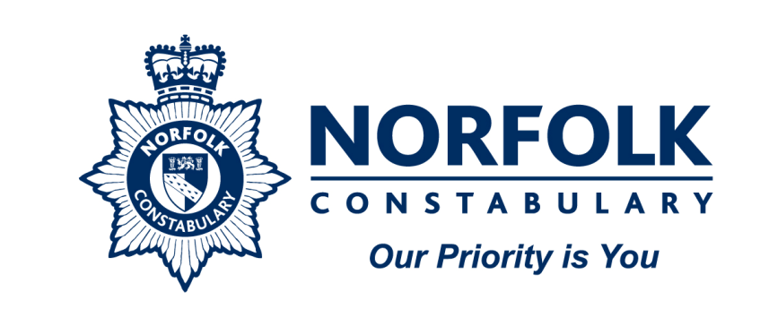

**NORFOLK MASH**

**Multi-Agency Safeguarding Hub: Referral Procedures**

**Where an agency/organisation or worker has concern for the welfare or safety of a child they can make a telephone referral via Care Connect by telephone on 0344 800 8020.**

**A telephone referral must then be confirmed in writing using the form marked** [**NSCB1**](http://www.norfolklscb.org/people-working-with-children/nscb-forms/)**, within a maximum of 48 hours, ideally 24 hours. The completed NSCB1 can be:**

* **Faxed to the MASH Team on 01603 762445**
* **Posted to: The MASH Team Manager, Floor 5, Vantage House, Fishers Lane, Norwich, Norfolk, NR2 1ET**
* **NSCB1 forms can also be e-mailed to MASH via** [**mash@norfolk.gcsx.gov.uk**](mailto:mash@norfolk.gcsx.gov.uk) **but must only be sent from a secure email address.**

**Safeguarding Consultation Line**

You can request a professional consultation if you are not clear about how to support a family and require further advice about a child. This is provided by the MASH Team. In order to access this service call Customer Services on **0344 800 8020** and state that you request a professional consultation. This procedure replaces the consultation service previously offered by the local Duty Teams.

Please note that consultations should not be used in circumstances where you suspect immediate risk or harm to a child e.g. when the child has made a disclosure of abuse or you suspect the child is presenting with a non-accidental injury. In these circumstances, you should contact Customer Services and explain that you wish to make a referral.